

Research Impact through Strategic Engagement

***A Reflexive Toolkit for Evidencing the Beyond Scholarly Impact of Research***

Developed by:

Associate Dean, Research, International & Innovation

Ontario Institute for Studies in Education

2023 ©

Cite as: Ladak, Z., Corso, C., Burns, S., Falenchuk, O., Hiratsuka, H., Cartmale, L., Taylor, M., & Peterson-Badali, M. (2023) *Research Impact through Strategic Engagement (RISE): A Reflexive Toolkit for Evidencing the Beyond Scholarly Impact of Research*.

# Table of Contents

**Research Impact** **1**

**RISE Framework** **2**

**Things to Consider as You Reflect on the Impact of Your Research** **3**

**Researcher Toolkit** **7**

**Tool 1: Types & Domains of Impact Conceptualization Matrix** **7**

**Tool 2: Research Outputs Table** **9**

**Tool 3: Knowledge Mobilization Activities Table** **10**

**Tool 4: Monitoring & Tracking Indicators of Impact Table** **11**

**Tool 5: Impact Planning Table** **14**

**Resources** **17**

# Research Impact

## What is research impact?

The impact of research can be thought of as the changes in perspectives, processes, and outcomes as a result of research that has been conducted. Research can have *scholarly* impacts—e.g., theoretical and methodological advances—and *societal* impacts—e.g., contributions to policy or public discourse that lead to changes in the society (Farley-Ripple, 2020). Research impact is not limited to what can be observed or measured and can include unintended outcomes, such as if research led to redirecting resources to a new equity-focused program, but an existing enrichment program was defunded in the process (Bornmann, 2013). Impact is also not limited to what has been “transmitted” to others, but can be thought of as the ways in which researchers, community, and research interact to create change. Impact can be directly linked to the research project (proximal impacts), or indirectly linked and the result of coalescing factors (distal impacts). Understanding the impact of research on individuals, communities, institutions, and society can help researchers communicate about the importance of their work and plan future projects.

## How can we track research impact?

Understanding research impact means answering the question, “What difference is my research making?” Given that impacts can be distal, unquantifiable, and cumulative, assessing research impact is no simple task. Just as OISE researchers come from different disciplines and rely on different methodologies, there is no one-size-fits-all in assessing research impact. Research impact may be communicated through many combinations of metrics or findings, including but not limited to narrative case studies, virtual analytics (e.g., downloads), or testimonials.

## The purpose of this toolkit

As OISE faculty are increasingly asked to speak to the impact of their research, the OISE Office of the Associate Dean, Research, International & Innovation (ADRII) has created this toolkit to aid them to define and identify the impacts of their scholarly programs. This is not an evaluative tool. We are mindful that, in the wider world, research impact assessment is sometimes used as a proxy for “valuing” research, and the “return on investment” of spending on research. In contrast, our intention is to support faculty members to reflect on ways in which their research has impact both within and beyond the scholarly community and how they can generate and use evidence to tell the stories of their research impact.

This toolkit will help researchers:

* Understand the difference between research outputs, knowledge mobilization activities, and evidence of research impact
* Identify intended impact and plan for collecting evidence of that impact

# RISE Framework

To create the toolkit, we first identified and analyzed existing frameworks of research impact to develop a novel research impact framework — Research Impact through Strategic Engagement (RISE) — that reflects our definition of and values around research impact. Different from other frameworks, which are focused on instruction and direction, RISE is framed for active engagement of the researchers to plan, monitor, and promote both the scholarly and ‘beyond scholarly’ impact of their research.

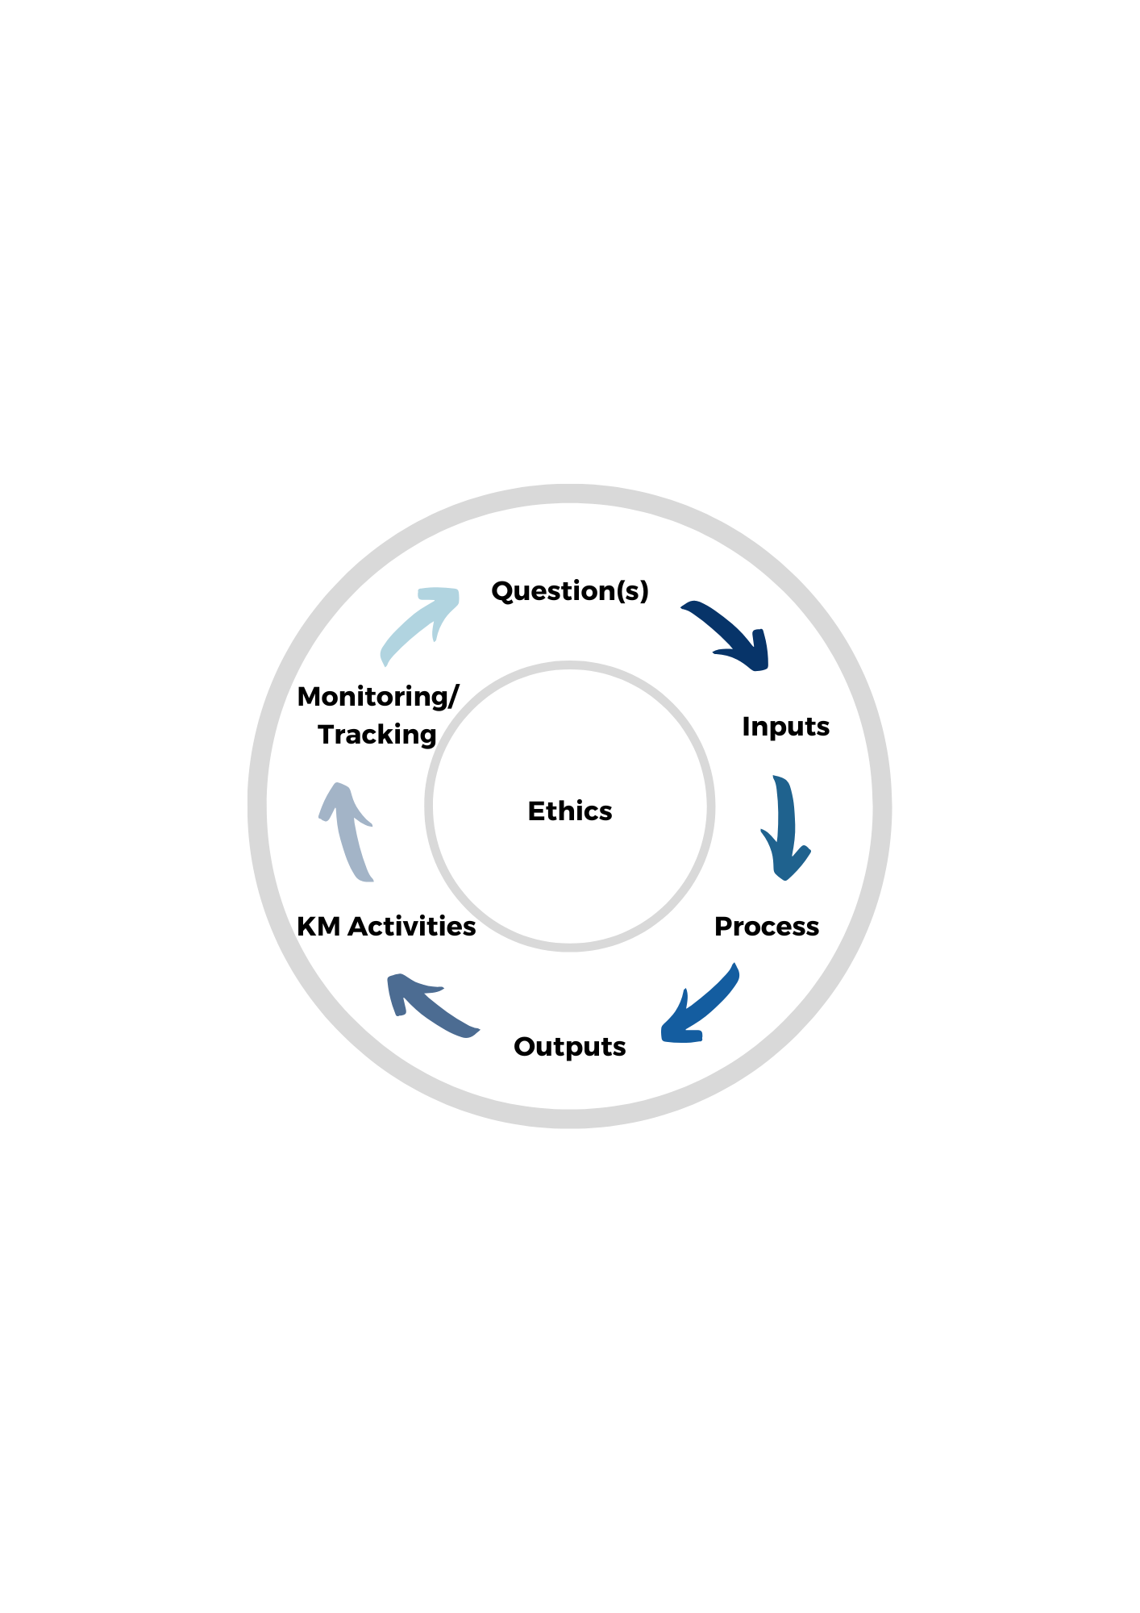In general, impact can be created within each phase of a **Research Cycle**. The research cycle is represented in the diagram below as a process consisting of six phases, each of which can have implications for impact. At the centre of this cycle is ethics, which is an integral consideration in all phases of research. Ethics, in this case, is not limited to the formalized Institutional Review Board processes but includes the broader ethical considerations of “Who is being served?” and “Whose perspectives are being sought?” throughout all stages of the Research Cycle.

While the RISE framework only focuses on three phases of the research cycle, note that any phase of the research cycle can generate impact and that the process of research can be as impactful as the output. And while, for ease of analysis, the research process is depicted as a cycle, we recognize that it can take multiple pathways and is often iterative.

# 

# Things to Consider as You Reflect on the Impact of Your Research

## Table 1. Phases of the Research Cycle

In the table below, we provide definitions for each phase, some reflection prompts, and examples of the impacts that can be seen. These are not meant to be an exhaustive list of the considerations or reflection questions related to each stage, but a starting point for discussion and planning. In this table, “groups” can refer to individuals, communities, professional bodies, or any other type of stakeholder in the research process. In some cases it might be possible to directly collaborate with the population being studied, but in other cases due to pragmatic or access issues, researchers may have more indirect access to a group’s needs. For example, collaborating with clinicians to understand the needs of children and youth living with mental illness.

|  |  |  |  |  |
| --- | --- | --- | --- | --- |
| **Phase** | **Definition** | **Considerations** | **Actors and Included Groups** | **Examples** |
| **Question(s)** | Developing your research question. In this stage you are identifying your topic of interest and laying the rationale for your planned work. | * What is the overall purpose of your research? * What are the potential and/or intended impacts of your research? Which ones are proximal? Which are distal? | * Who is your research serving (directly and indirectly)? * Who helped in identifying these issues? * What groups do you need to engage with to determine your questions? | * Co-creating research questions with practitioners to articulate community needs   *\*See Types & Domains of Impact Conceptualization Matrix* |
| **Inputs** | The material and non-material investments to carry out your project. | * How will your inputs target your outputs? * Will your choice of inputs affect your overall impact? * What is the nature of the collaboration with any communities or groups that are involved with this project? | * What groups are you collaborating with in this project? * What positionality and theoretical perspectives do you and the research team bring to the project? * To what extent does the research team reflect the populations being studied? | * Collaborators and community partners   *\*See Types & Domains of Impact Conceptualization Matrix* |
| **Process** | The course of action taken to carry out your procedures of data collection and analyses. | * What data, methods, and analyses will give you the most information for your intended impact? * What is the most productive way to conduct this research for the community? | * Who are your participants and how are they being impacted by the research process? * Have we added or removed barriers for participants in accessing resources? * Who is represented in your data? | * Participatory research * Interviews * Interventions * Training   *\*See Types & Domains of Impact Conceptualization Matrix* |
| **Outputs** | The products and artifacts from your research project | * What modes/media of the research outputs will help to deliver the research ideas in the best way? | * For what audience(s) is this product intended? * Who helped create this product? * Whose voices are heard in this product? * Have you unintentionally excluded any groups? | * Art and media * Professional development materials * Research resources * Scholarly documentation  *See Research Outputs Table |
| **KM Activities** | The activities to distribute the novel research knowledge to target audiences | * How, where, and when will you reach your target audience(s)? * What proximal levels of impact are most logical for your research findings? * What distal levels of impact will your proximal impact lead to? | * Who is/are your target audience(s)? * Does this target audience align with your anticipated proximal or your anticipated distal impacts? * Have your target audience(s) changed since the inception of the project? | * Broadcasting * Formal events * Informal communication   *\*See Knowledge Mobilization Activities Table* |

|  |  |  |  |  |
| --- | --- | --- | --- | --- |
| **Monitoring / Tracking** | The evidence of your research impact on an individual, group, community, or global level through tracking tools and indicators of research impact | * What is the impact you want to sustain and at which level? * What monitoring tools are best suited for you to convey the impact? * What indicators will you look for to provide evidence of the impact? | * Who would you expect to be impacted? * Who have you asked about impact? * Have you unintentionally excluded any groups? | * Evidence of changed perspectives (e.g., testimonials, critical conversations) * Evidence of changed processes (e.g., policy changes, professional standards) * Evidence of changed outcomes (e.g., government and policy reports)  *See Monitoring & Tracking Indicators of Impact Table |

## 

## Research Impact through Strategic Engagement (RISE)

The RISE framework focuses on the last three of the six phases of the research cycle – Outputs, Knowledge Mobilization (KM) Activities, and Monitoring/Tracking – and their interconnections. As mentioned above, impact is not limited to these three phases.

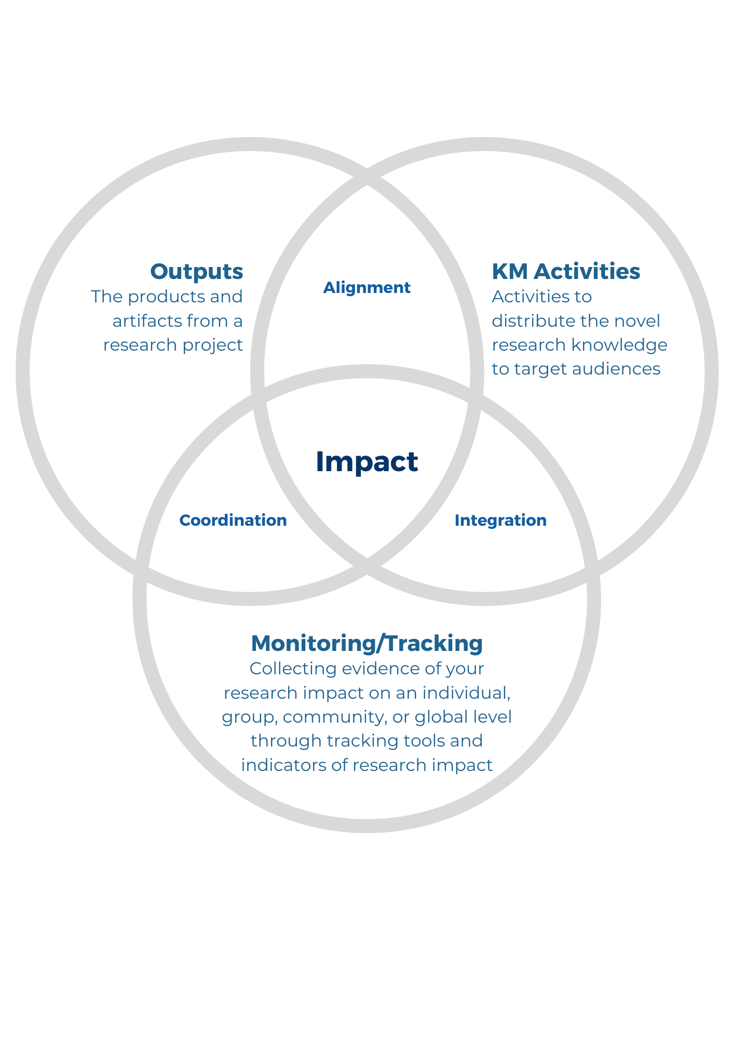

In this model, *alignment* is ensuring that outputs are appropriate for the planned KM activities so that they will reach the target audience. For example, if you hope to reach a vulnerable community with your KM activities, then you may need to create an informative but accessible informational product, such as an infographic or brochure.

*Integration* refers to the way in which you organize monitoring/tracking to complement KM activities. For example, if you are presenting your research, you may be able to embed activities or tools to gather feedback from the audience about changed perspectives.

Finally, *coordination* refers to the process of establishing how outputs meet your expectations for monitoring/tracking. For example, if you plan on tracking changes in practitioner behaviour as a result of your research, you might weigh the value of publishing a manuscript against designing an interactive workshop.

# 

# Researcher Toolkit

The purpose of this toolkit is to provide a practical guide and a set of templates to engage researchers in actively planning for and reflecting on their research impact, based on the RISE framework. The toolkit can be used for a variety of different purposes:

* Planning a new research project
* Reporting on impact of the past projects to funders
* Conversation starter with community partners or collaborators
* Collecting evidence of impact across an entire career

# Tool 1: Targets & Domains of Impact *Conceptualization* *Matrix*

To help you identify the areas of your research impact, we put together the matrix of the targets and societal domains of impact. This matrix can be useful at multiple stages of a research process. Researchers are encouraged to use it when conceptualizing their research questions and thinking about the target domains of their research. You may also use it at the stage of designing the research outputs and knowledge mobilization activities to reach your target audiences and achieve impacts. The intent of this matrix is to help in the brainstorming process to consider how your research creates a purposeful ‘story’ from conceptualization to impact, while integrating all phases of the research cycle.

To optimally use this matrix, use the open spaces to jot down your thoughts and ideas. Further, the ‘Targets’ and ‘Domains’ listed here are to be broadly defined, based on your paradigm and views as a researcher. For example, Prof. Fikile Nxumalo’s research on climate justice education with Black urban families can create impact in the Domains of Education, Environment & Sustainability, and Justice (at a minimum); and Prof. Kathleen Gallagher’s drama research can create impact in the Domains of Arts & Culture, Education, and Health & Wellbeing (at a minimum).[1]

The targets and domains of impact specified in this matrix are commonly found in educational research. However, these categories are not exhaustive or mutually exclusive.

|  |  |  |  |  |  |  |  |  |
| --- | --- | --- | --- | --- | --- | --- | --- | --- |
|  | |  | **TARGET OF IMPACT** | | | | | |
|  | |  | Community Engagement | Innovations & Inventions | Knowledge Production / Theory Building | Policy | Practice | Other |
| **DOMAIN OF IMPACT** | Arts & Culture | |  |  |  |  |  |  |
| Economics | |  |  |  |  |  |  |
| Education | |  |  |  |  |  |  |
| Environment & Sustainability | |  |  |  |  |  |  |
| Health & Wellbeing | |  |  |  |  |  |  |
| Justice | |  |  |  |  |  |  |
| Other | |  |  |  |  |  |  |

# 

# 

# Tool 2: Research Outputs *Table*

Research outputs are the primary, short-term **products** that are created to explain research findings. Research outputs can take a variety of forms: from more traditional journal publications and conference presentations to entrepreneurial ventures, blog entries, podcasts, and social media highlights. The table below contains examples of research outputs in different categories; other examples not listed may be more applicable to your research and can be added to this table.

|  |  |  |  |  |
| --- | --- | --- | --- | --- |
| **ART & MEDIA** | **PROFESSIONAL DEVELOPMENT MATERIALS** | **RESEARCH RESOURCES** | **SCHOLARLY DOCUMENTATION** | **OTHER** |
| * Artistic works * Blogs * Creative writing * Films/videos * Magazine articles * News items * Podcasts * Press releases * Social media posts * Website content * Other | * Seminar materials * Learning or teaching modules * Handouts * Presentation slides * Exemplars * Online repositories * Fact sheets * Video recordings * Other | * Protocols * Contracts * Databases * Patents * Licensed resources (e.g. apps, instruments) * Toolkits * Other | * Journal articles * Book/book chapters * Conference proceedings * Reports * Theses/ dissertations * Program/ curriculum outlines * Briefs * Case studies * Other |  |
| *Use the space below to fill in your project’s research outputs* | | | |  |
|  |  |  |  |  |

# *Adapted from Research Impact Canada,* [*Knowledge Mobilization Planning Template*](http://www.kmbtoolkit.ca/sites/all/themes/kmb/assets/images/Knowledge_Mobilization_Planning_Form.pdf)

# Tool 3: Knowledge Mobilization Activities *Table*

Knowledge mobilization (KM) is the reciprocal and complementary flow and uptake of research knowledge between researchers, knowledge brokers and knowledge users in such a way that may benefit users and create positive impacts. The process of KM involves a researcher planning KM activities. Within our framework, KM activities act as a link between research outputs and research impact. These activities allow the research knowledge to reach knowledge users. Planning and conducting KM activities does not guarantee that impact will be created. Therefore, KM activities are necessary but not sufficient condition for creating impact and without KM we cannot have impact.

The table below contains examples of KM activities in different categories; other examples not listed may be more applicable to your specific research area and your career stage, and can be added to this table. KM activities may also be organized by target audience.

|  |  |  |  |
| --- | --- | --- | --- |
| **CONVERSATIONS & NETWORKS** | **EVENTS** | **MEDIA &  WEB PRESENCE** | **OTHER** |
| * Informal conversations * Scheduled conversations * Emails * Other | * Lectures * Workshops * Conferences * Invited speaking engagements * Public events * Book launches * Public debates * Other | * Radio, TV and podcast interviews * Social media * Newspaper and magazine interviews * Other |  |
| *Use the space below to fill in your project’s KM activities* | | | |

|  |  |  |  |
| --- | --- | --- | --- |
| **CONVERSATIONS & NETWORKS** | **EVENTS** | **MEDIA &  WEB PRESENCE** | **OTHER** |
|  |  |  |  |

# 

# Tool 4: Monitoring & Tracking Indicators of Impact *Table*

Monitoring and tracking are distinct activities within the research process and are necessary to gather evidence of your potential research impact. These activities should be planned and incorporated into your research process. We cannot assume that our research has made an impact; we need evidence of it. The tables below contain examples of monitoring and tracking methods and indicators associated with impact; other examples not listed may be applicable to your research and can be added to this table. The methods are meant to be used to identify indicators that show awareness of your outputs and KM activities, and to identify indicators that show evidence of the uptake of your outputs and KM activities. This process of monitoring and tracking will help in identifying any impacts that were intended or unintended. *(When considering unintended impacts, it is encouraged to be mindful of ethics within your research process; how do these unintended impacts influence different communities?)*

|  |  |  |  |
| --- | --- | --- | --- |
| *Proximal - - - - - - - - - - - - - - - - - - - - - - - - - - - - - - - - - - - - - - - - - - - - - Distal* | | | |
| **METHODS** | **EVIDENCE OF CHANGED PERSPECTIVES** | **EVIDENCE OF CHANGED PROCESSES** | **EVIDENCE OF CHANGED OUTCOMES** |
| **Data collection from target populations**   * Surveys * Interviews / critical conversations * Focus groups * Observations * Testimonials |  |  |  |
| **Document analysis**   * Policy documents * Government reports * Legislative documents * Citations in policy and practice documents |  |  |  |
| **Altmetrics**   * Social media analytics (e.g., retweets, views, followers, likes) * Tracking web data * Download counts |  |  |  |
| **Other** |  |  |  |

# 

# Tool 5: Impact Planning *Table*

We suggest that the researchers use the following table at the stage of designing their new research projects. Addressing the questions below will help to plan for research outputs, KM activities, and methods for tracking impact that align with the research objectives, intended impact, and target audiences. We offer the researchers an opportunity to reflect on the questions below and fill in the template. You can also find our example for this exercise in the table below.

* What impact do I want to have?
* Who do I need to reach to make this happen? (target population)
* What research outputs will I produce to make this happen?
* What is the best way to deliver KM activities for each audience?
* What method of tracking/monitoring impact do I use for each KM activity?
* What data/indicators will I collect for each method of tracking impact?

All tools presented to you above will contribute at this stage. For example, the matrix of types and domains of impact should help you decide on the intended impact and the target audiences. The other tools will directly lead you to reflection about your research outputs, KM activities, and monitoring/tracking of impact.

**IMPACT PLANNING TABLE - EXAMPLE**

|  |  |  |  |  |
| --- | --- | --- | --- | --- |
| **INTENDED IMPACT** | | | | |
| ***DISTAL*** | Improved financial literacy and well-being for Canadians | | | |
| ***PROXIMAL*** | Improve teaching and learning in the area of financial literacy | | | |
| **TARGET POPULATION** | **RESEARCH OUTPUTS** | **KM ACTIVITIES** | **METHODS OF TRACKING IMPACT** | **DATA / INDICATORS FOR TRACKING IMPACT** |
| Teachers | Repository of curriculum resources and lesson plans | Promotion of resources by direct contact of school boards  Professional social media | Online metrics  Asking teachers for testimonials | Number of downloads  Number of likes, tweets, retweets, etc.  Testimonials |
| Professional development resources | Workshops  Webinars | Pre-post survey | Survey data |
| Researchers in the field | Manuscript | Submission to a peer-reviewed journal  Submission to a professional conference | Bibliographic metrics  Attendance at the conference | Number of citations  Number of attendees |
| Canadian society |  |  | Statistics Canada | Reduced number of bankruptcies  Improved credit scores |

# 

# *Use the space below to plan your project’s impact*

|  |  |  |  |  |
| --- | --- | --- | --- | --- |
| **INTENDED IMPACT** | | | | |
| ***DISTAL*** |  | | | |
| ***PROXIMAL*** |  | | | |
| **TARGET POPULATION** | **RESEARCH OUTPUTS** | **KM ACTIVITIES** | **METHODS OF TRACKING IMPACT** | **DATA / INDICATORS FOR TRACKING IMPACT** |
|  |  |  |  |  |
|  |  |  |  |  |
|  |  |  |  |  |
|  |  |  |  |  |
|  |  |  |  |  |

# Resources

## Useful Readings & Resources

Bornmann, L. (2013). What is societal impact of research and how can it be assessed? a literature survey. In Journal of the American Society for Information Science and Technology (Vol. 64, Issue 2, pp. 217–233). <https://doi.org/10.1002/asi.22803>

SSHRC (2019). Guidelines for Effective Knowledge Mobilization. Government of Canada. Retrieved May 10, 2022: <https://www.sshrc-crsh.gc.ca/funding-financement/policies-politiques/knowledge_mobilisation-mobilisation_des_connaissances-eng.aspx>

Research Impact Canada: <https://researchimpact.ca/>

* [Guide to Impact Planning](https://researchimpact.ca/kmb_resource/guide-to-impact-planning/)
* [A Guide to Setting Your Knowledge Mobilization Goals](https://researchimpact.ca/wp-content/uploads/KMb-Goal-Setting.pdf)
* [Knowledge Mobilization Planning Template](https://researchimpact.ca/kmb_resource/knowledge-mobilization-planning-template/)
* [Impact and Engagement Case Study Guidelines](https://researchimpact.ca/kmb_resource/impact-and-engagement-case-study-guidelines/)
* [Knowledge Engagement Impact Assessment Toolkit](https://researchimpact.ca/kmb_resource/knowledge-engagement-impact-assessment-toolkit/)

[U of T Public Policy Reports Collection](https://tspace.library.utoronto.ca/handle/1807/80309)

[Overton.io](https://www.overton.io/) - searchable database for policy documents

OISE Library [Grey Literature / Altmetrics Search Strategy](https://utoronto.sharepoint.com/:w:/r/sites/oise-adrii/resources/_layouts/15/Doc.aspx?sourcedoc=%7B6126089F-732F-4349-825E-68637AE17370%7D&file=Grey%20Literature%20(Altmetrics)%20Search%20Strategy.docx&action=default&mobileredirect=true&cid=5cca6a48-3d02-42f1-b664-f750bc070901) and [Template](https://utoronto.sharepoint.com/:w:/r/sites/oise-adrii/resources/_layouts/15/Doc.aspx?sourcedoc=%7B5B5CF826-1DF1-48C6-A4A7-4867D7096EE8%7D&file=Grey%20Literature%20Search%20Template.docx&action=default&mobileredirect=true)

## The ADRII Team

Faculty can meet with any one of the members from the Office of the ADRII to learn more about research impact, the RISE model, and working with this toolkit.

**ADRII Home Site:** <https://www.oise.utoronto.ca/research/Contact_Us.html>

**Contact:** [oise.research@utoronto.ca](mailto:oise.research@utoronto.ca)**,** 416-978-1117

**Michele Peterson-Badali**

Associate Dean, Research, International & Innovation

**Lara Cartmale**

Director, Research & International Initiatives

**Olesya Falenchuk**

Research Systems Analyst

**Brian Kalakula**

Research Partnership Development Officer

**Lisa Smith**

Contracts and Information Officer

**Madeleine Taylor**

Strategic Research Development Officer

1. These examples were drawn from OISE social media accounts.