
NEWSLETTER | FALL 2021



Director’s Message Inside this Issue
- Director’s Message
- Honors and Awards
- Community News
- Community Titles
- CIDE Student Association
- CIDEC Interest Groups
- CIDE Fall 2021 Graduates
- CIDE Faculty, Alumni, and
Students’ Publications

Welcome to new and returning members of the CIDE/C community! I’m pleased to announce that 50 new students have joined the CIDE Collaborative Specialization as of September and we wish them (you) all a productive and rewarding learning journey.
Before going further, I want to recognize the tireless work and leadership of outgoing CIDE/C Director, Professor Kathy Bickmore, and thank her for her many valuable contributions. My transition into the role of CIDE/C Director has been that much smoother and enjoyable as a result of Kathy’s many achievements in this role. A special thanks is also owed to our incredible administrator, Sazna Aliyar, for all that she does to ensure the efficient and effective operations of CIDE/C.
It has been a pleasure to work with our new CIDEC GA, Dareen Charafeddine, an EdD student in LHAE/ELP. It’s because of Dareen that our newsletter looks a bit different from those in the past – I hope you find this new format even more accessible and visually appealing. Feedback is always most welcome!
The Fall 2021 edition of the CIDEC newsletter is brimming with inspiring details of the accomplishments of our faculty and students. Congratulations to Dr. Elizabeth Buckner on receiving the Connaught New Researcher Award. Congratulations to Michael Connelly on receiving an Honorary Doctorate from the Education University of Hong Kong. Congratulations to John Portelli, Miglena Todorova, and Patricia Carbajal on their new books. Congratulations to recent CIDE graduate, Dr. Jill Carr-Harris on receiving the Dr. Ursula Franklin Award of Excellence from the Canadian Voice of Women for Peace. And last but certainly not least, congratulations to our 16 graduating students – all the best going forward (and please keep in touch!).
Thank you to Norin Taj (PhD candidate, LHAE/ELP) for sharing some engaging excerpts from interviews with families in Pakistan concerning girls’ education. Thank you to Greg Tyrosvoutis (EdD student in the International Educational Leadership and Policy program/LHAE) for sharing details on recent research on multilingual education (MLE) and Indigenous teachers in Karen state, Myanmar. And thank you to Oleg Legusov (PhD candidate, LHAE/HE) for sharing details of his doctoral research on the experiences of Ontario community college graduates from former Soviet republics as they transition from school to work.
You’ll also find in this newsletter important information from the new CIDE Student Association (CIDESA) co-chairs, Lois Boody and Sudhashree Girmohanta about CIDESA activities and how to get involved. I encourage all students to complete the short questionnaire at the link provided and share your thoughts and ideas. The newsletter also offers important information concerning the activities of several CIDE/C Interest Groups (IGs) and how to get involved. IGs are student-led and often involve CIDE-affiliated faculty as well. If you wish to initiate a new IG, please contact the CIDESA (cidesa.oise.uot@gmail.com).
Congratulations to all faculty and students on their recent publications and other activities as detailed in the content to follow.

Warm wishes,

Carly Manion, CIDE/C Director
Honours and Awards
Inside this Issue
HoHownhflafafagag
Inside this Issue

Connaught New Researcher Award



Dr. Elizabeth Buckner

Congratulations to Professor Elizabeth Buckner who was awarded the Connaught New Researcher Award for her innovative research on sustainable development in
education.

Buckner, who joined OISE in 2017, examines comparative and higher education – specifically, sustainable development and globalization and their effects on those institutions.
The Connaught New Researcher Award is designed to help early career faculty members establish a strong research program and increase their competitiveness for external funding.
To learn more about her research, read the interview with Dr. Buckner by OISE News.

Fall 2021 | Page No. 2


Dr. Ursula Franklin Award
Congratulations to Dr. Jill Carr-Harris for receiving the Dr. Ursula Franklin Award. Here is what Dr. Carr-Harris had to say about the award.

It happened all so quickly. Finishing my dissertation and being accorded doctoral status this past June. Took place on zoom. There was little fanfare. It was all done.

Just the year before I had taken time off from my doctoral studies to be one of the leaders of an international peace march known as the Jai Jagat (Victory to the World) that was struggling to reaffirm peace and justice in 12 countries (www.jaijagatinternational.org). With the onset of the COVID pandemic, we were compelled to stop the march halfway, after six months. Surprisingly, this gave me renewed energy to resume my writing on educational leadership at the height of the lockdown.

Now looking at the title of the bound volume: A Study on Nonviolence: Constructing Narratives of Leadership, with the University of Toronto crest dominating the cover, I want to believe that these narratives will contribute to leadership studies in future broadening the discussion beyond western stereotypes.

Throughout the Jai Jagat and the dissertation, I learned that leaders matter. In particular I think of Dr. Ursula Franklin who aspired in the scientific fields (physics and metallurgy) at University of Toronto after the war to become one of the first woman scholars in her field. Ursula went beyond her own career and ensured opportunities for many of her women colleagues in opposing long-standing gender barriers. Ursula was not satisfied with achieving institutional reform, for she went on to carry out much broader social reform. By opposing war, and in particular nuclear war, she used her stature as an academic, Quaker and public intellectual to strengthen an anti-war movement that influenced genuine policy change towards nuclear disarmament.

In May 2021, I was fortunate to receive the Dr. Ursula Franklin Award from the Canadian Voice of Women for Peace. Although it seems like a large vision to live up to, I was honored to be this year’s recipient. For more information on the award and about Dr. Ursula Franklin, please visit: https://vowpeace.org/peace-awards/
Fall 2021 | Page No. 3
Honorary Doctorate Award

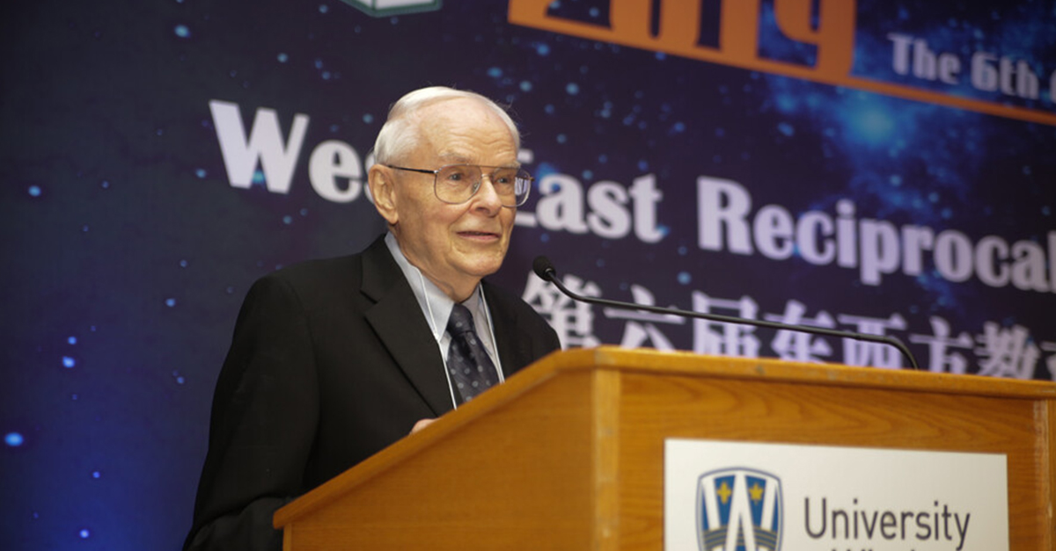

Dr. Michael Connelly

Congratulations to Professor Emeritus Michael Connelly who will be receiving an honorary doctorate award from the Education University of Hong Kong on December 6, 2021
A leading authority in the field of curriculum and instruction, Connelly joined OISE in 1968 and is renowned for his work on curriculum studies, science education, school reform, teacher education and development, and multiculturalism.
The founding director of the OISE Centre for Teacher Development, now called Continuing and Professional Learning, he was also a director of a Hong Kong Institute of Education/OISE Doctoral Program, and a founder and editor of Curriculum Inquiry. His hundreds of publications include The Sage Handbook of Curriculum and Instruction and Narrative Inquiry for School-based Research. His many accolades include Outstanding Canadian Curriculum Scholar Award from the Canadian Society for the Study of Education; Whitworth Award for Educational Research from the Canadian Education Association; and American Educational Research Association (AERA) Outstanding Publication Award.

Source: University of Toronto Website
https://www.utoronto.ca/celebrates/michael-connelly-receive-honorary-degree-education-university-hong-kong

Fall 2021 |Page No. 4
Community News
Inside this Issue
HoHownhflafafagag

A measuring stick, not the measuring stick for MLE: A tool, a Karen case study, and discourse in support of MLE best practices

By: Greg Tyrosvoutis

This research was a joint effort with the Karen Education & Culture Department where the multilingual competencies of Karen teachers were assessed. Our research approach sought to witness ‘organic teaching’ without teachers preparing elaborate lesson plans tailored to the outcomes assessors were looking for. Teachers did not know what competencies the observers were assessing and therefore had little opportunity to prepare. This case study demonstrated that indigenous teachers in Karen State possess a collection of the MLE (Multilingual Education) teacher competencies highlighted and recommended throughout international literature as best practices of teaching and learning. Either as a product of their training or realized by working in multilingual environments, this sample of Karen teachers possessed a solid foundation of MLE competencies.

New MLE interventions in Karen state need not start from scratch: Karen teachers have been successfully teaching in multilingual environments for decades and possess a wealth of expertise. Diverse multilingual classrooms require teachers who: understand, speak, read and write the students’ L1 and the official school language(s); share students’ heritage and culture; are respected by parents and the wider school community; and are accepted by local authorities.

Only local teachers can fulfil these needs. Indigenous teachers need to be involved in every step of MLE interventions and recognized for the critical role they play in safeguarding ethnic minority cultures and heritage. To access the full article, visit: https://asiapacificmle-bucket.s3.us-east-2.amazonaws.com/image/BC-Academic%20papers-4.Greg%20Tyrosvoutis%20%5BA4%5D_Jul_2.pdf

Greg is a second year IELP EdD student with a CIDE specialization. He co-authored this article along with Saw Shar Nay Thaw, Naw Mee Lay, Naw Paw Su Klay, Saw Nay Ta Mu, Naw Paw Htoe Ki Wah, Nan Eh Sar Klain, Th’Blay Moo and Naw Nay Yu Paw.

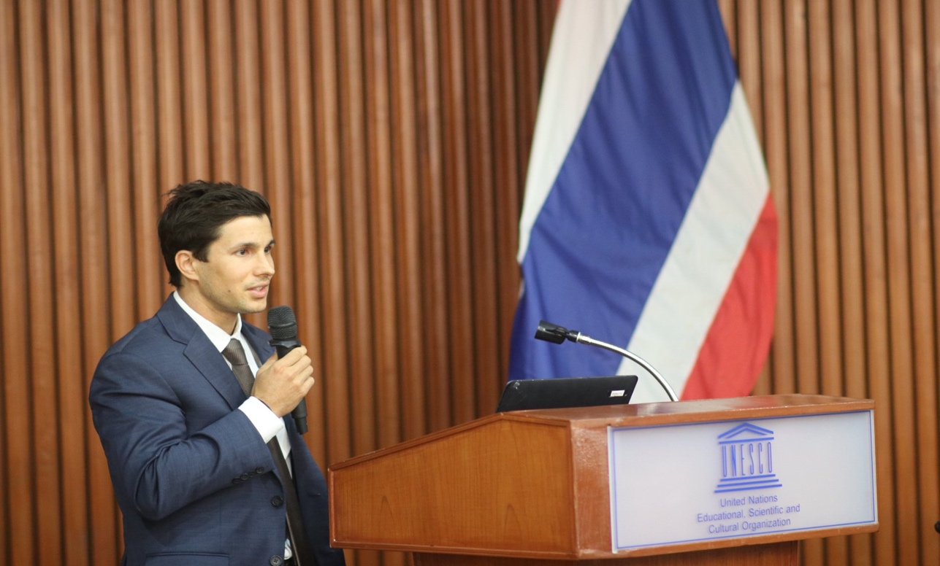

Fall 2021 | Page No. 5
Spring 2021 | Page No. 4

Student Research Snapshot
By Norin Taj

Given the global consensus on the role of education and its connection to gender in policy work, my research study explores the key issues and clusters of meanings of the global concepts related to girls’ education that exist in a local urban context in Pakistan. The study adopts a relational approach with the everyday decision-making and anecdotes of parents’ support for their daughters first, and then putting those in a general policy context while attempting to understand the refraction of global ideas.

Here, I am presenting a snippet of one of interviews with a parent in Karachi. Notice how the educated urban parent faces the challenge of following and reproducing the traditional, prescribed gender roles, deeply rooted in the society, while aspiring to educate his daughters.

Fall 2021 | Page No. 6

:Qکیا آپ کے بیٹے کے لیے بھی یہ لفظ استعمال ہو سکتا ہے یا اگر ہو تو کِس طرح سے ؟
:Aبیٹوں کے لیے کیا نہیں جاتا لیکن میں بہت کرتا ہوں اور یہ بھی میری ہمیشہ سے خواہش رہی ہے کہ بیٹے کو بھی ہے نا اتنا ٹرینڈ ہونا چاہیے مطلب میں اگر مطلب میں آج تک مجھے افسو س ہے کہ میں نے کبھی انڈا فرائی کرنا نہیں سیکھا یہ میری حسرت رہی ہے اُس کی وجہ میں صبح ناشتے میں انڈا بوائل تو کر لیتا ہوں میں فرائی نہیں کر پاتا تو میں نے بیٹے کو کہا کہ بیٹا فرائی کرنا کم از کم ضرور سیکھ لو لیکن خیر اُسکی اپنا یہ ہے کہ اُس کو کھانے پکانے میں بھی کچھ انٹرسٹ رہتا ہے لیکن یس ، اس حوالے سے میں بالکل ہی equally treat کرتا ہوں مطلب میری خواہش ہے کہ میرے بچوں کو جو ہے نا واش روم سے لے کر گھر کے دوسرے معاملات میں بیٹے کو صفائی کرنا بھی آئے اُن کو کچھ نا کچھ کھانا پکانا بھی آئے اور اُن کو ہر وہ کام جو ہے آنا چاہیے جو کہ ہم گرلز کے لیے expect کرتے ہیں.same

Q 2: Can borem be used for your son as well? If yes, then how would you describe that?
A: (It is) not used for sons but I use it a lot. And I always wanted that (my) son should similarly be trained. I mean… I still regret that I never learned to fry eggs, that being my wish… therefore I boil eggs for breakfast but can’t fry them so I advised my son to at least learn to fry an egg. Anyways, he has some interest in cooking but yes, I treat them equally. I wish that my son should learn some cleaning and cooking…and (all) the housework that we expect from our daughters.

:Qتو کیا گھر میں کام کاج میں مدد کرتی ہیں؟
:Aہاں، مطلب اس میں مزاج کے اوپر بڑا depend کرتا ہے ابھی آپ کے سامنے میری چھوٹی والی جو ہے اُس کا بس نہیں چلتا کہ اپنی ماں کے بھی کام کرنا شروع کر دے لیکن جو بڑی والی ہے ٹھیک ہے مطلب اُس کو کہنا پڑتا ہے کہ یہ تمہارا کام ہے تمہیں یہ کرنا ہے مطلب جان چُھڑانی ہے بس اگر کھانا لگانا ہے کھانا سمیٹنا ہے تو ٹھیک ہے اب یہ ڈیوٹی ہے تو بس صحیح ہے وہ willing نہیں اُس کو مطلب کہ ہاں جی مجھے پڑھنا ہے تو بس مجھے پڑھنا ہے لیکن یہاں مطلب لیکن یہ بھی ہمارا ایک وہ ہے کہ بچیوں کو جو ہے وہ اس حد تک ٹرینڈ ہونا چاہیے کہ جب ultimately شادی کے بعد جائیں تو بالکل ہی جو ہے پتا نہیں آپ کو یہ ورڈ اچھا لگ رہا ہے بورم ، ہمارے ہاں ایک لفظ چُوز کیا جاتا ہےبورم ، بورم یہ ہوتا ہے کہ بالکل ہی کچھ آتا جاتا نہیں ہے تو ہم بچوں کو کہتے ہیں کہ ایسی سچوئیشن ہے کہ بالکل ہی شادی کے موقعے پہ بالکل ہی بورم اتنا کچھ آتا جا تا ہو کہ ساس یہ نہ کہے تمہاری کہ ماں نے کچھ بھی سِکھا کہ نہیں بھیجا ۔
Q 1: So, does she help in household chores?
A: Yes, I mean… It depends on her mood. You see the younger one (sitting in front of you), she can’t help herself from doing even her mother’s chores, but the elder one needs be to be told that this is your work and you have to do it…I mean she doesn’t want to (take the initiative herself) … like setting up and tidying the table is done as a duty. So, I guess that’s that she is not willing (to do household chores) as she wants to study. But this also our (concern) … that daughters should be trained to some extent so when they are married they are not…I don’t know if you would like this term…but they are not borem. Borem is a word (in our community) which means someone who doesn’t know anything. So, we caution our children that don’t be a borem by the time you get married…(learn) something so that (your) mother-in-law doesn’t announce that (your) mother didn’t train you on anything.

:Qبورم لڑکے کے لیے بھی ہو سکتا ہے؟
:Aہونا چاہیے لیکن ہمارے ہاں پھر بھی کہا نہیں جاتا اُس کی وجہ یہ ہے وہ کہا جاتا ہے کہ being a male اگر آپ ایک بات کہہ رہے ہیں تو مطلب ہے کہ آپ نے اپنے لڑکے کو بالکل ہی بیوقوف سمجھ لیا ہے تو آپ لڑکی کو بیوقوف سمجھ سکتے ہیں لڑکے کو نہیں سمجھ سکتےچاہے وہ اُس کو آدھا کام بھی نا آتا ہو یہ ایک مطلب ایک ہے میں پرسنلی اس چیز پہ believe نہیں کرتا ذاتی طور پر میں اس کے بہت against ہوں ، میں کہتا ہو ں بھئی جہاں جس کو کوئی کام کرنا ہے اُس کو وہ کام کرنا ہے۔ اب یہ نا سوچیں وہ لڑکا کر رہ ہے یا لڑکی کر رہی ہے۔

Q 3: Can borem be used for boys, in general?
A: It should be…but we don’t use it. Because if you are (using the term borem) for a male, it means you think your son is a complete fool…so you can consider a girl a silly but you can't think of a boy (to be silly), even if he is not familiar with half the work. I don’t believe in this and personally I am against this. I maintain that whoever needs to, has to do work…don’t think that it is a boy or a girl doing the chore.

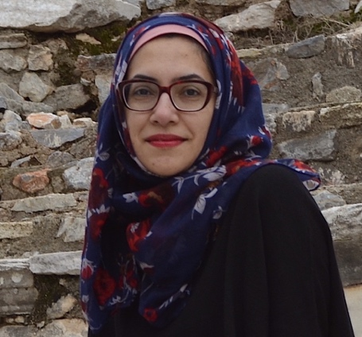
Fall 2021 | Page No. 7

Parent Interview- March 2019, Karachi, Pakistan
Research Study: When global ideas meet local contexts—The case of girls’ education in urban Pakistan

Norin Taj is a PhD candidate in the program of Educational Leadership and Policy with a specialization in Comparative, International and Development Education.

: Qتو کیا ایسا ممکن ہے کہ لڑکے کے لیے الگ طرح کا کام اور لڑکیوں کے لیے الگ طرح کے کام؟
: Aہے ، ایسا ہی ہے فیکٹر میں اپنے گھر کی حد تو نہیں کہہ سکتا لیکن it’s for sure کہ ہمارے ہاں ایسا ہی ہے کہ اگر گھر میں مطلب آپ کو چائے بھی بنانی ہے تو ہمارے ہاں تو مطلب ماں بنائے گی یا وہ بہن بنائے گی یا وہ بیٹی بنائے گی لیکن لڑکا خود نہیں بنائے گا۔ کیونکہ یہ تو لڑکے کا کام ہی نہیں ہے چائے بناناصرف چائے بنانااور آجکل تو خیر ٹی بیگ کا کانسیپٹ ہے اُس کے باوجود نہیں ہے۔ اسی طرح سے کوئی اگر ٹھیک ہے گھر کی صفائی کا معاملہ آ گیا تو یہ کام تو ماسی کا ہے یا پھر اگر ماسی کا یہ کام نہیں ہے تو پھر گھر کی جو خواتین ہیں وہ کریں گی چاہے وہ پنکھے ہی کیوں نا صاف کرنا ہوں میں کہتا ہوں یار یہ پنکھا میں کہتا ہوں کہ جتنا اچھی طریقے سے as a male میں صاف کر سکتا ہوں کبھی کوئی لڑکی نہیں کر سکتی کبھی نہیں کر سکتی۔ کیونکہ میں یہ کام کرتا ہوا آیا ہوں تو میں نے اپنی اولاد سے بھی یہ expect کیا اب وہ خیر وہ الگ بات ہے وہ وقت کے ساتھ ٹرینڈ میں ایک چینج آتا ہے کہ مطلب اس کی ضرورت کیا ہے صفائی کی وہ تو پہلے تو یہ ہوتاہے یہ صاف تو نظر آ رہا ہے خیر یہ ہمارے ہاں ایک جنرل ہےکہ نا صفائی کے کام میں کھانا پکانا تو بالکل تو خیر کوئی بہت دور کی بات ہے کچن میں جانا تو لیکن اگر ہمارے ہاں یہ کانسیپٹ ہےکہ اگر آپ کھانا کھانے کے بعد وہ پلیٹس کچن میں بھی لے کے جا نا ہے تو یہ لڑکے کا کام نہیں ہے اس کو بہت بُرا سمجھا جاتا ہے۔ کہ یہ تو کام ہی بیوی کا بہن کا یا ماں کا ہے کہ وہ کھانا کھانے کے بعد کھانا سمیٹ کےجو ہے نا وہ لے کے جائے گی الحمد وللہ میں نے یہ کوشش کی کہ بچوں کو اس حد تک ٹرینڈ کیا کہ اس میں ہمارے ہاں باقاعدہ وہ ڈیوٹیز ہیں کہ آج کا کھانا یہ سمیٹے گا ۔

Q 4: So, is it possible that there are different types of tasks for boys and different for girls?
A: It is like this. I can’t say this for my house but (generally) it is like this (in our society). I mean if you have to make tea (so for our society) the mother will make it or the sister will make it or the daughter will make it but the boy will not make it himself because it is not a boy’s task even though (we have) the tea bags available but still no. Similarly, if it is house cleaning then it is the job of female servants, if they don’t do that then the women of the house will do it even if they have to clean the (ceiling) fans. I (often) this ‘man, this fan…the way I can clean (this) as a male no female can ever clean it as good as I would. Never.’ Since I have been doing these chores, I expect the same from my children...but (now) they (ask) why do we need to clean it when it looks clean? … the trends (of parenting) are changing. Anyways, it is very common (in our society) that helping in cleaning… and cooking is for sure a far cry…so stepping in the kitchen or taking plates to the kitchen after the dinner are not considered to be boys’ tasks, it is considered very bad. These tasks are for mothers, sisters or daughters. Alhamdulillah, I tried to train the children to such an extent that we have regular duties that will cover today's table tasks.

Research Overview
By Dr. Oleg Legusov

“Using Bourdieu’s Theory of Practice to Investigate the Experiences of
Ontario College Graduates from Three Former Soviet Republics”

With an aging population and a looming shortage of skilled labour, the Canadian government wants to attract more international students in the hope that many will stay on after graduation. For most international graduates the path to citizenship involves securing suitable employment in Canada. This study used a mixed-methods research design that combined qualitative data with descriptive statistics and comparative analysis to explore the experience of 30 Ontario community college graduates originally from three former Soviet republics – Russia, Ukraine, and Belarus – as they attempted to transition from school to work and to integrate into Canadian society. Even though research on the labour-market outcomes of international graduates in Canada is advancing, it tends to emphasize university graduates. Moreover, there is scant research on international students from nonvisible minority groups who try to transition to life in Canada. This study seeks to address this knowledge gap.

Pierre Bourdieu’s theory of practice provided the theoretical framework used to analyze the participants’ work and integration experience. The study examined the relationship between structure and agency, as well as the interplay of the three elements of Bourdieu’s theory: field, capital, and habitus. The data collected from in-depth interviews and document analysis revealed that each participant belonged to one of three distinct groups: “Teenagers”, or those who arrived in Canada shortly after graduating from high school; “Young Adults”, or those who were in their 20s and had further life experience on arrival; and “Mature Adults”, or those who were over 30 on arrival, leaving behind established lives.

Before coming to Canada, many members of the Teenager group already had attitudes and attributes suited to Canada’s career field. They also possessed considerable cultural and economic capital as a result of opportunities provided by their parents. The Teenager participants were therefore similar to their Canadian peers in many ways but also retained their original cultural identity. Thus, it was concluded from the study findings that they possessed a bicultural habitus and were well equipped to succeed on the career field in their new country.

The participants in the Young Adult group could not come to Canada right after high school and therefore spent several years engaged in various activities in their home countries, gaining experience that gave them a career habitus not well aligned with the Canadian labour market. A characteristic feature of the Young Adult group is their divided, or cleft, habitus. Unlike the members of the Mature Adult group, who arrived in Canada with a well-formed habitus or those in the Teenager group, whose primary habitus was still developing during their college years, the participants in the Young Adult group had a relatively well-established habitus when they arrived in Canada yet were young enough for it to be shaped by their new environment.

And the salient feature of the Mature Adult Group was that, even though some were still young when the Soviet Union collapsed, socialism had a profound impact on their habitus in general and career habitus in particular. Accordingly, they had the greatest difficulty adjusting to life in Canada.

This research is pertinent from theoretical and practical points of view. The study’s main contribution to Bourdieusian theory is that varied groups of individuals from the same culture can have drastically different configurations of habitus. The study findings show that the rules governing the Canadian career field disproportionately favour individuals with certain types of habitus and disadvantage others. The study also contributes to scholarship on nonvisible minority immigrants’ experience in the host country’s labour market. It offers empirical evidence of the

Fall 2021 | Page No. 8
intersectional complexity of ethnic privilege experienced by international college graduates from Russia, Ukraine, and Belarus in the Canadian labour market. As members of a nonvisible Caucasian minority, the participants often found themselves negotiating complex power relations in career fields. The study revealed that, even though they experienced prejudice and discrimination as newcomers to Canada, their whiteness served as a form of capital in the job market, and they readily took advantage of their status when it served their objectives.

The research findings have several implications for Canada’s labour market. With an aging labour force and a growing need for employees with international and intercultural competence, Canadian companies can benefit from employing immigrants with different cultural and socioeconomic backgrounds. This study clearly demonstrated that the substantial cultural capital of mature international college graduates is undervalued in the Canadian labour field, even though such capital can be highly beneficial to the success of Canadian businesses. Furthermore, although habitus constitutes an individual’s durable dispositions, it is not constant and is capable of transformation, especially when an individual enters an unfamiliar field. Hence, if mature immigrants are treated fairly in a career field, their habitus will have a better chance of adjusting to the rules of the game and, in the process, of influencing the rules and the field itself. For such an outcome, however, the laws and regulations governing labour relations need to support a more equitable distribution of power in career fields.

Several measures were taken to strengthen the study’s trustworthiness. Even so, further insights could be obtained from larger-scale quantitative or mixed-method research. Moreover, the same theoretical approach and an identical or similar methodology could be used to investigate the experience of international college graduates from other ethnic groups in the Canadian labour market. Also, to explore whether the research findings have broader implications, rather than being specific to a particular group, further research could examine the experiences of mature international college graduates from countries that have also undergone traumatic change. Such societies include post-apartheid South Africa, Iraq since the fall of Saddam Hussein, and countries that were not part of the Soviet Union but were nonetheless affected tremendously by the collapse of the Soviet bloc, such as East Germany, Bulgaria, and Poland. Countries with divergent political and economic systems, such as North Korea and Cuba, could also undergo major transformation at some point, presenting yet another opportunity for research on this subject.

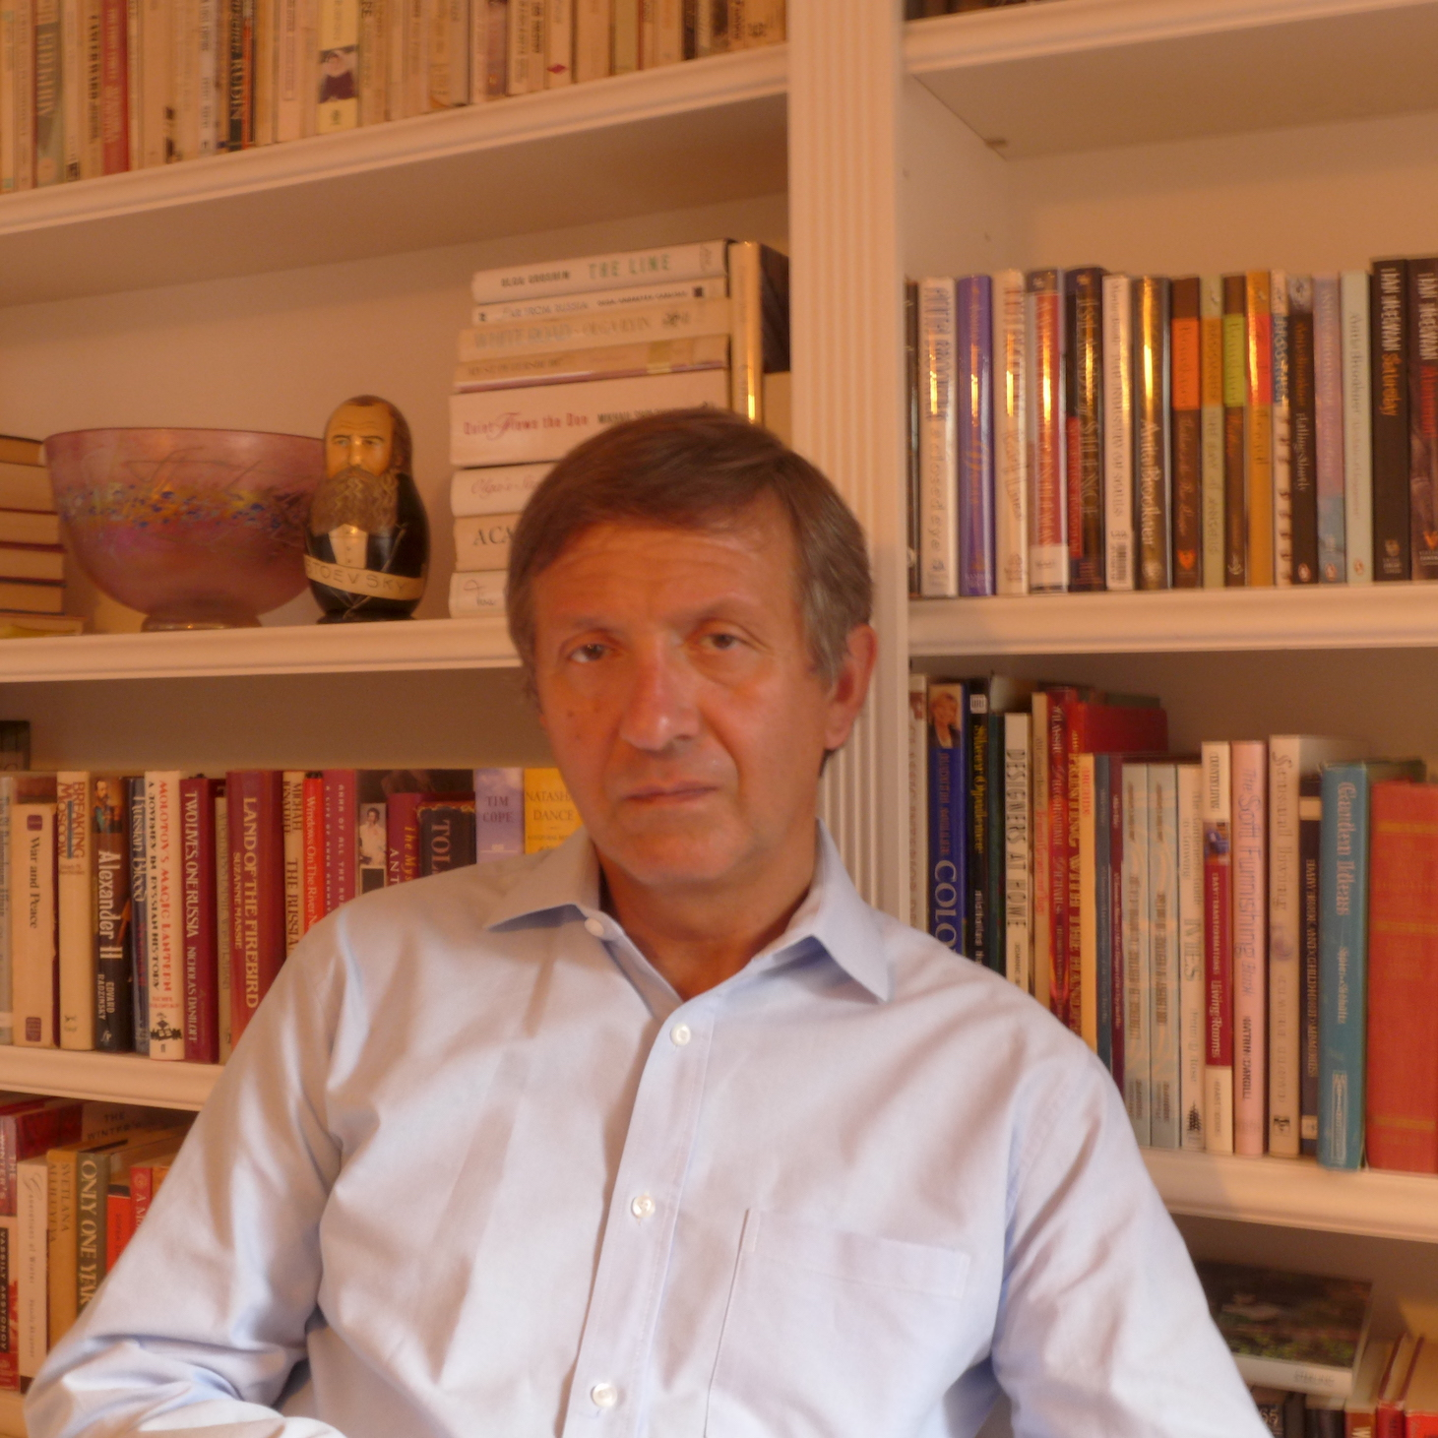
Image: Recent CIDE graduate Dr. Oleg Legusov (LHAE/Higher Education)
Fall 2021 | Page No. 9
Community Titles
Inside this Issue
HoHownhflafafagag
Everyone but Fajza: A Novel by Professor John P. Portelli


About Everyone But Fajza:
Everyone but Fajza (Burlington, ON: Word & Deed, 2021).
John P. Portelli

Media reports erupt when Fajza is discovered with gunshot wounds, unconscious and abandoned next to one of Toronto’s most violent high schools. As she lays in a hospital bed, those closest to her must grapple with the hand each of them played in her uncertain future. Through their narratives, an image of Fajza emerges; the wife of a prominent businessman, a child of Maltese-Turkish immigrants, a woman struggling to find her identity, a jealous sister.

About the Author:

Dr. John P. Portelli is an award-winning Maltese Canadian author and educator. He has published 23 books including seven collections of poetry, two collections of short stories, and over 100 articles and chapters in books. Two of his books won the American Educational Studies Association Critic Award, and another of his books won the Canadian Association for the Foundations of Education Book Award. He is an excellent and engaging speaker and instructor with an international reputation and proven record, having made over 100 presentations at national and international conferences. He is frequently invited to give keynote addresses and workshops in his areas of research and teaching which include: narratives of migration and exile; continuous professional development and quality assurance; student engagement and students ‘at risk’; teaching controversial issues; intercultural education and dialogue; equity and ethical issues in policy and leadership; social justice education.

Fall 2021 | Page No. 10

Comparative and International Education: Leading Perspectives from the Field

About the Book

Comparative and International Education: Leading Perspectives in the Field
is edited by Beverly Lindsay, the first
African American President of CIES (1988-89). In this book she brought together chapters by eleven CIES Honorary Fellows who share their thinking and scholarly journeys. One of the four women comparativists included was Professor Ruth Hayhoe from OISE. Her chapter entitled, Comparative Education and the Dialogue Among Civilizations, which “reflects on Comparative Education and Comparative Higher Education in relation to the emergence of the Dialogue of Civilizations after the end of the Cold War.” (Hayhoe, R., 2021, p. 71)

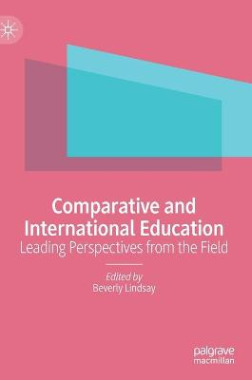

Here is an article that Dr. Hayhoe has written to highlight some of the points in her chapter. It recently appeared in a new on-line journal edited by Anatoly Oleksiyenko, at the University of Hong Kong’s Comparative Education Research Centre.

More About Professor Hayhoe
Ruth's research has mainly related to Chinese higher education and educational relations between East Asia and the West. She has been interested in the ways in which cultural values and epistemologies from Eastern civilizations may provide a resource for new thinking in global higher education development. She is also interested in the intersection between Asian ways of knowing and women's ways of knowing, and questions of gender in cross-cultural leadership, topics stimulated by her personal experience of institutional leadership in an Asian context.

References:
Department of Leadership and Higher Education Website, OISE, University of Toronto. https://www.oise.utoronto.ca/lhae/Faculty/384/Ruth_Hayhoe.html

Hayhoe, Ruth (2021), Comparative Education and the Dialogue Among Civilizations. In B. Lindsay (Ed.), Comparative and International Education: Leading Perspectives in the Field. (pp. 71-84). Palgrave Macmillan

Fall 2021 | Page No. 11

Unequal Undersocialism: Race, Women and Transnationalism in Blugaria
By Miglena S. Todorova

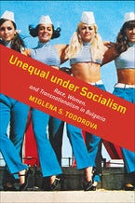
About the book
A new book by Dr. Miglena Todorova, Associate Professor in Social Justice Education at OISE, has been published by the University of Toronto Press. Entitled Unequal Under Socialism: Race, Women and Transnationalism in Bulgaria (2021), the book contributes to the emerging field of “post-socialist studies” a transnational feminist theoretical and methodological paradigm for mapping and understanding the intertwined local and global forces, such as public education, driving racialization, socialist state policies, and Eurocentric Marxist and Leninist ideologies, all of which led to the making of valued and devalued categories of women in the socialist society.

In Bulgaria, a former socialist country in the Balkans, Roma women, Muslim women, ethnic Bulgarian women, sex workers, and female factory and office workers were among those marked by socialist authorities for prosperity, accommodation, violent reformation, or erasure.

Covering the period from the 1930s to the present and drawing upon original archival sources as well as a constellation of critical theories, Unequal under Socialism focuses on the lives of different women to articulate deep doubt about the capacity of socialism to sustain societies where all women prosper. Such doubt, the book suggests, is an under-recognized but important force shaping how women in former socialist countries have related to one another and to other women in the global North and South.

About the Author

Dr. Miglena S. Todorova is an associate professor in the Department of Social Justice Education and Director of the Centre for Media, Culture, and Education at the Ontario Institute for Studies in Education, University of Toronto. Her research interest is in
transnational feminism(s); women, race, and empires; gendered and sexual violence prevention in higher education, postsocialism; globalization, critical social and cultural theories, critical media literacy education, qualitative methods of research and analysis.

Fall 2021 | Page No. 12

Modelo de convivencia para atender, prevenir y erradicar la violencia escolar
By Patricia Carbajal and Cecilia Fierro

Patricia Carbajal and Cecilia Fierro

About the Book

Public education policies oriented to prevent school violence have been established in numerous Latin American countries, including Mexico. However, this goal seems to be elusive. Grounded on solid international research evidence, this book presents a school Convivencia Model that goes beyond control-based dispositions and regulations, and emphasizes the transformation of pedagogical and organizational practices in order to facilitate the development of nurturing environments and capacity building. Under this perspective, convivencia means building sustainable peaceful relations by implementing inclusive, equitable and participatory practices in schools and classrooms.

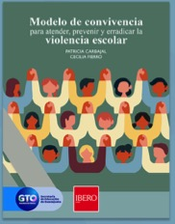

This Convivencia Model represents an accessible tool for analyzing public policies, designing teacher development initiatives and/or self-diagnostics, as well as for conducting research in this field. This book also represents a successful example of constructive dialogue between public policy makers (Ministry of Education of the State of Guanajuato, Mexico) and educational researchers (Universidad Iberoamericana Leon).

The Authors
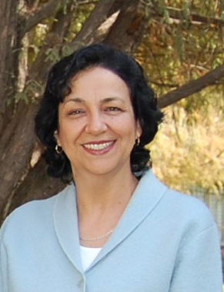  Dr. Patricia Carbajal  CIDE Alumnus | 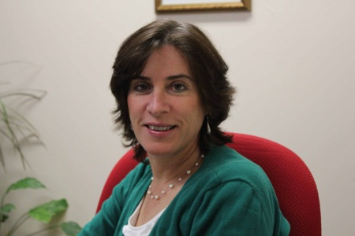  Dr. Cecilia Fierro

Fall 2021 | Page No. 13

Who We Are!
Student Association (CIDESA)!afbakg
CIDE Student Association (CIDESA)




Lois Boody
CIDESA Co-Chair

Sudhashree Girmohanta
CIDESA Co-Chair

Warm greetings from the CIDE Student Association (CIDESA)!
Here is a bit about us and what we have been up to:
The CIDESA is a student organization that aims to foster a sense of community among CIDE students through various events and activities. CIDESA also liaises between students, CIDE administration, and faculty to communicate student ideas, questions, and concerns.
This year’s CIDESA Co-chairs are Sudhashree Girmohanta, a PhD student in the Languages and Literacies program, and Lois Boody, an MEd student in the Social Justice Education program.
We were very pleased to meet many new CIDE Students in breakout rooms following the CIDE Orientation on September 9th, and we also hosted our first event of the year on September 24th - the CIDESA Welcome Social! It was wonderful to get together online and chat with new and returning CIDE students and faculty members. Interest group leads were present and shared a bit about what they do too, and we discussed what kinds of events we would like to have going forward.
We also want to hear from you! What would you like to see from CIDESA this year? Would you like to get involved? Please fill out this quick questionnaire to have your say!
Please also feel free to email us at cidesa.oise.uot@gmail.com with any questions or comments, or if you would like to get connected with the CIDESA WhatsApp group.
We look forward to hearing from you and to meeting you at upcoming events!
- Sudhashree & Lois

Fall 2021 | Page No. 14
The Education, Conflict & Peacebuilding group started off the year with a meeting on October 14th for existing and new members of the community. ECP will continue to meet monthly, which will involve a mix of a member sharing their research and a space for open discussion. In addition to these monthly meetings, there will be a series of workshops, seminars, and other programming that respond to emerging interests of the group. Please email ecp.oise@gmail.com to be added to the mailing list.
ECP is also delighted to launch our Education, Conflict & Peace Reading Group, in collaboration with Seoul National University's Education, Conflict and Peace Lab (ECP), and the University of Cambridge Peace and Education Research Group (CPERG). An international team will co-facilitate four (2-hour) weekly sessions, where participants will discuss readings at the intersections of peace, conflict and education. This is an inclusive space catering for people at all stages of their learning! Please register here: Education, Conflict & Peace: Reading & Dialogue Group [Registration] (google.com)

CIDEC Interest Groups (IGs)

Education, Conflict and Peacebuilding Group
Student Association (CIDESA)!afbakg

Immigrant and Refudge Education Research IG

Responding to the continued education and integration concerns of the increasing number of immigrants and refugees in Canada, a number of faculty and students at OISE decided to establish an Immigrant and Refugee Education Research Interest Group at OISE and located the group within CIDE. On Thursday October 7, 2021, with 28 attending, the Immigrant and Refugee Education Research Interest group had its first OISE-wide virtual welcome meeting. Currently the group is led by Profs., Emmanuelle Le Pichon-Vorstman, and Antoinette Gagné and Sarfaroz Niyozov. The meeting generated many ideas for upcoming activities ranging from reading groups to presentations and a mini-conference. The meeting also illustrated that a wide range of interests and engagement exists among OISE faculty and students in the field, ranging among research, policy, development and teaching around education and societal integration of refugees and immigrants in Canada and internationally. CIDEC’s long-held collaboration with Midaynta Community Center is one of such involvements. If you are interested in joining the group please contact s.bahry@utoronto.ca.

Fall 2021 | Page No. 15
The Eurasia Research Interest Group, consisting of Prof. Niyozov, Drs. Stephen Bahry, Max Antony-Newman, Yecid Ortega, and doctoral candidate, Zahra Jafarova, MT student, Kateryna Pashchenko, and new member, OISE grad, Dr. Oleg Legusov met on Zoom on Wed Oct 6 to talk about their interests and recent and possible future activities. Building on their work over the summer preparing a SSHRCH proposal with Dr. Niyozov as PI on education of children and youth from post-Soviet families in Canada, the group has submitted a presentation proposal to CIESC 2022, and building further on the group's research on teachers and post-Soviet parents, a proposal is being prepared for CIES on engagement during the pandemic of teachers in Canada with parents from Ukraine, Brazil, Palestine.

Dr. Bahry and Tojiniso Olimnazarova (University of Central Asia senior lecturer, PhD candidate University of Alberta) have a forthcoming chapter, "English in Tajikistan" in the Wiley-Blackwell Encyclopedia of World Englishes and are submitting proposal to CIES on multilingualism and education in Tajikistan and Kazakhstan, Central Asia. Prof. Niyozov and Dr. Bahry have a forthcoming chapter, "Decolonization of education research, policy-making, and practice in Central Asia: The case of Tajikistan" in the 2021 Annual Review of Comparative and International Education, and are also co-authors with colleagues at Nazarbayev University, Kazakhstan (OISE grads Profs. Duishon Shamatov & Mir Afzal Tajik) and Coventry University, UK (Prof. Mehmet Karakuş) on a presentation proposal to CIES on their current research project in support of SDG4 in education in Central Asia, "Exploring school-based education stakeholders’ perspectives on quality of education in Kyrgyzstan and Tajikistan".

The Eurasia Research Interest Group

The Eurasia Research Interest Group, consisting of Prof. Niyozov, Drs. Stephen Bahry, Max Antony-Newman, Yecid Ortega, and doctoral candidate, Zahra Jafarova, MT student, Kateryna Pashchenko, and new member, OISE grad, Dr. Oleg Legusov met on Zoom on Wed Oct 6 to talk about their interests and recent and possible future activities. Building on their work over the summer preparing a SSHRCH proposal with Dr. Niyozov as PI on education of children and youth from post-Soviet families in Canada, the group has submitted a presentation proposal to CIESC 2022, and building further on the group's research on teachers and post-Soviet parents, a proposal is being prepared for CIES on engagement during the pandemic of teachers in Canada with parents from Ukraine, Brazil, Palestine.

Dr. Bahry and Tojiniso Olimnazarova (University of Central Asia senior lecturer, PhD candidate University of Alberta) have a forthcoming chapter, "English in Tajikistan" in the Wiley-Blackwell Encyclopedia of World Englishes and are submitting proposal to CIES on multilingualism and education in Tajikistan and Kazakhstan, Central Asia. Prof. Niyozov and Dr. Bahry have a forthcoming chapter, "Decolonization of education research, policy-making, and practice in Central Asia: The case of Tajikistan" in the 2021 Annual Review of Comparative and International Education, and are also co-authors with colleagues at Nazarbayev University, Kazakhstan (OISE grads Profs. Duishon Shamatov & Mir Afzal Tajik) and Coventry University, UK (Prof. Mehmet Karakuş) on a presentation proposal to CIES on their current research project in support of SDG4 in education in Central Asia, "Exploring school-based education stakeholders’ perspectives on quality of education in Kyrgyzstan and Tajikistan".

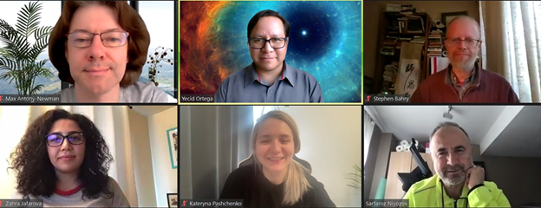

Please see the CIDE/C website for further information on Interest Groups: https://www.oise.utoronto.ca/cidec/cidec-interest-groups/

Fall 2021 | Page No. 16
Introducing the CIDE Book Club

What is CIDE Book Club?
Welcome! This is a CIDE-run, no-credit, no-obligation social reading group. Much like a brunch book club among friends, CIDE’s book club is a lunch book club open to anyone in the CIDE or OISE extended family (faculty, students, alumni). We read new books and monographs that are related to the field of comparative, international and development education and discuss them, purely because we want to!

How can I participate? You just have to read the book (or as much of it as you can) and come ready to discuss – what did you think? What was interesting, enlightening, problematic, unconvincing?

When and where do we meet? Someday, we hope to meet in person again – _but for now, we will meet monthly on Fridays at lunchtime (12pm-1pm Eastern) on Zoom. You can bring your lunch! We will meet in Elizabeth Buckner’s Personal Zoom Room: https://oise-utoronto.zoom.us/j/4207031124

Can I get a CIDE seminar credit for participating in CIDE Book Club? Yes! This is a new initiative, so on a preliminary basis, CIDE has decided that up to 1 seminar credit (of the required 5) can come from reading and participating in a Book Club meeting this year. You will be expected to read the whole book and be ready to discuss! We will record names of those who would like a CIDE seminar credit at the meeting. You can participate in as many book club meetings as you like, but only one can receive a CIDE seminar credit.

Other Questions? Email: Elizabeth Buckner (CIDE Affiliated-Faculty in Higher Education) elizabeth.buckner@utoronto.ca

2021-2022 CIDE Book Club Selections: This year’s list of books has been curated by Dr. Elizabeth Buckner but in the future, we hope to have a more participatory process of selecting books to read!

- October Meeting (past): The Inconvenient Generation [Minhua Ling]
- Friday, November 26, 12-1pm: Global Development and Human Rights: The Sustainable Development Goals and Beyond (Paul J. Nelson) [One copy available at UofT Libraries]
- Friday December 17, 12-1pm: Teach for Arabia (Neha Vora) [Full text available at UofT Libraries]
- Friday January 21, 12-1pm: International Aid to Education (Francine Menashy) [One copy available at UofT Libraries]
- Friday February 25, 12-1pm: When the Light is Fire (Heather D. Switzer) [One copy available at UofT Libraries]
- Friday March 25, 12-1pm: Coercive Concern (Reva Jaffe-Walter) [Full text available at UofT Libraries]

Fall 2021 | Page No. 17
Fall 2021 CIDE GRADUATES
Inside this Issue
HoHownhflafafagagCCo
CONGRATULATIONS!
Inside this Issue
HoHownhflafafagagCCo

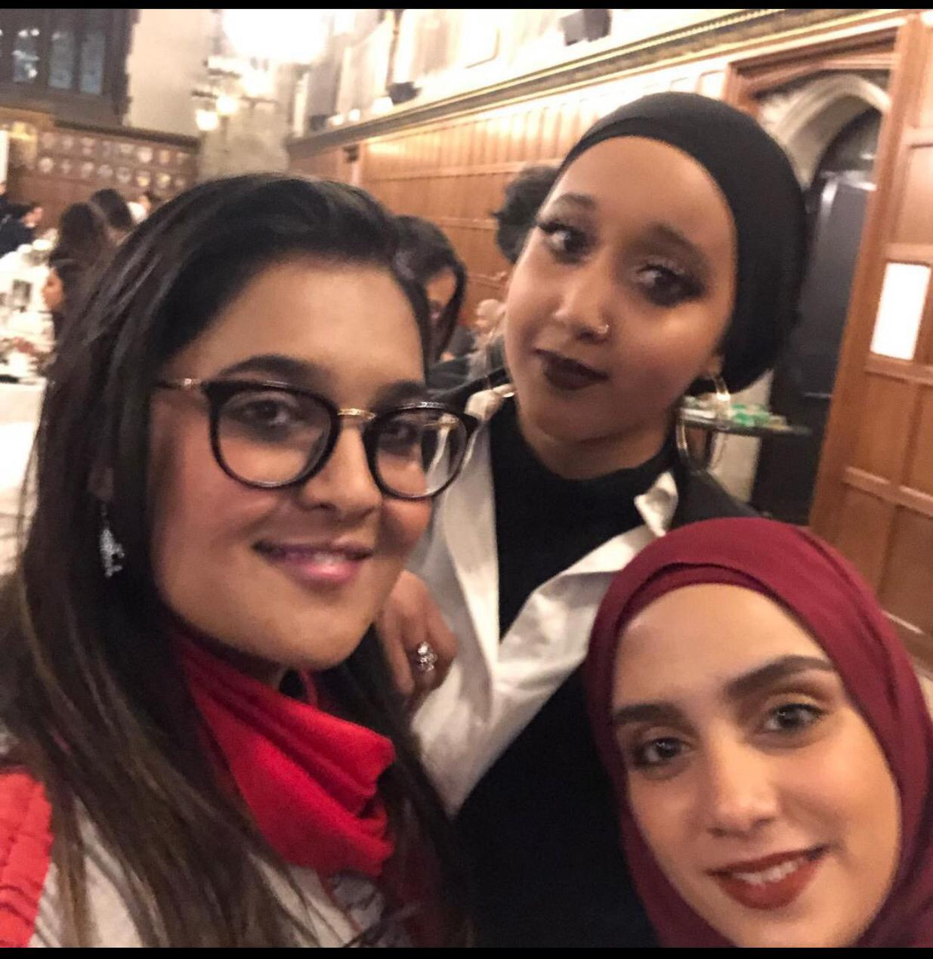

- Edmund G. Adam
- Gillian Carr-Harris
- Chandra McIvor
- Sakina Saherwala
- Kelsey McIver
- Gauravi Lobo
- Aayah Amir
- Hanin Masri
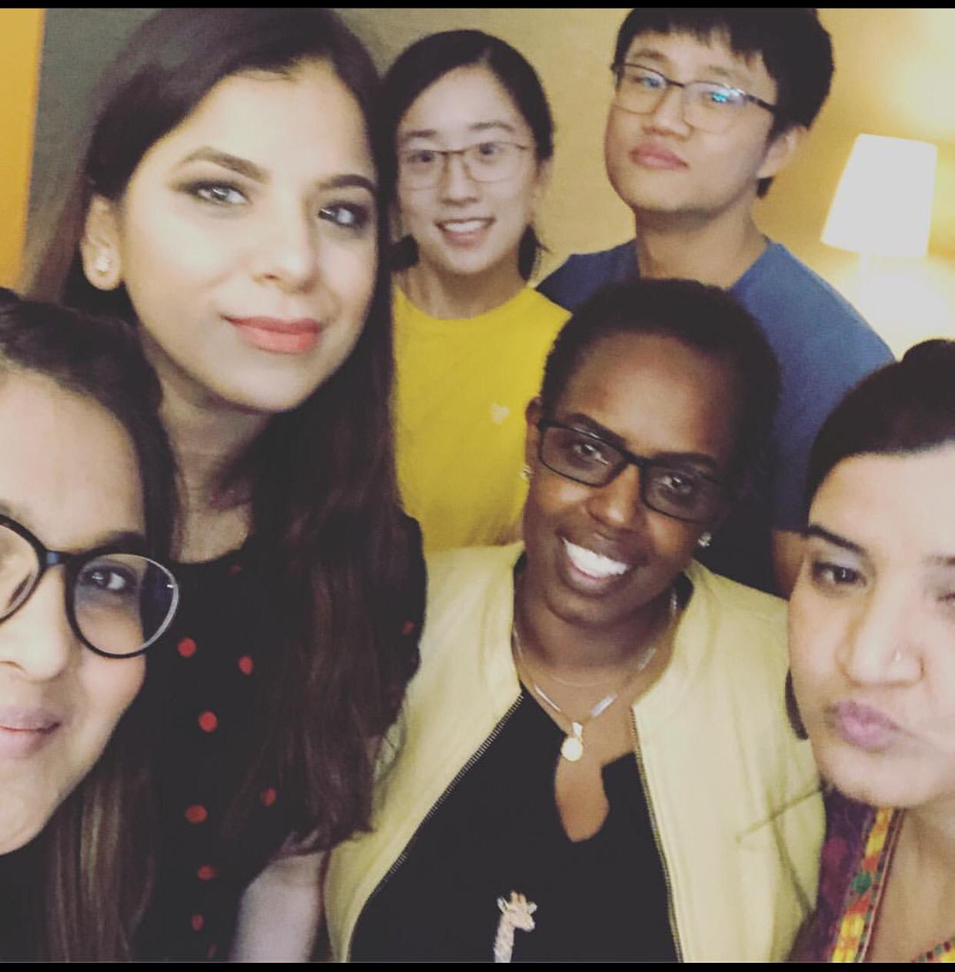
- Yecid Ortega Paeez
- Ramesh Kumar Pokharel
- Daniela Lombardo
- Mirzadeh Nazanin
- Kalauti Henry
- Sahar Itani
- Pushpa Hamal
- Hina Touseef

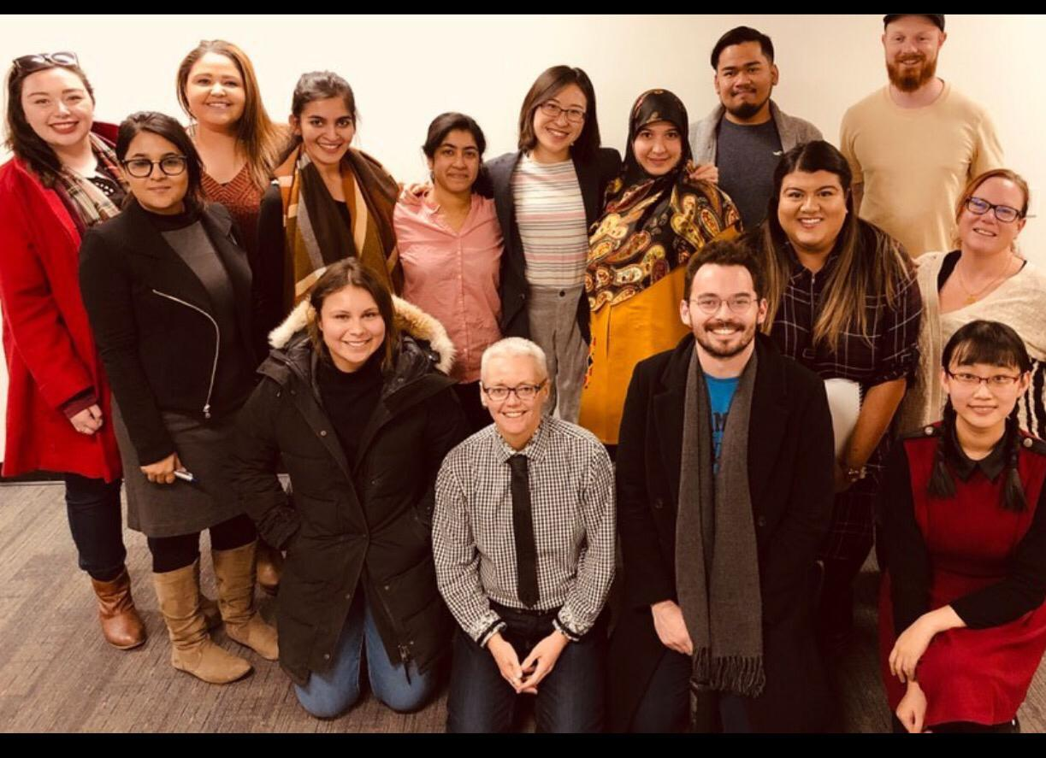
Fall 2021 | Page No. 18
Inside this Issue
HoHownhflafafagagCCo
CIDEC Faculty, Alumni and Students’ Publications

Bickmore, K. & Fathallah, R. (Forthcoming 2021). Teaching Social Justice amidst Violence: Youth and Enacted Curricula in Canada, Bangladesh, and México. In Abdi, Ali, Misiaszek, Greg (Editors) International Handbook on Critical Theories of Education. Palgrave.

Bickmore, K. & Barrero, D. (Forthcoming 2021). Globalized Local Environmental and Resource Conflicts in Mexican and Canadian Youths’ Lives and Schooling: Silenced Citizenship Questions. In Kubow, P., Strong, K., Webster, N. & Miranda, D. Contestations of Citizenship: Children and Youth, Democracy, and Education in an Era of Global Change. Routledge.

Bickmore, K., & Kaderi, A. S. (2021). Teaching Values for Comprehensive Just Peace? Teachers’ Curricula for Social Cohesion in México, Bangladesh, and Canada. Chapter 7 in C. Carter (Ed.), Teaching and Learning for Comprehensive Citizenship: Global Perspectives on Peace Education (pp. 114-140). New York and Abingdon, UK: Routledge.

Flessa, J., Bramwell, D., & Mindreau, G. C. (2021). Educational Administration Research in Comparative Education, 1995–2018. Comparative Education Review, 65(3), 419-444.

Hayhoe, R. (2021). Comparative Education and the Dialogue Among Civilizations. In B. Lindsay (Ed.), Comparative and International Education: Leading Perspectives in the Field (pp. 71-84). Palgrave Macmillan.

Menashy, F., and Manion, C., (forthcoming 2021). The Political Economy of Global Education Policy. In K. J. Saltman and N. Nguyen (eds.), Handbook of Critical Approaches to Politics and Policy of Education. Routledge.

Mundy, K. and Manion, C. (forthcoming 2021). The education for all initiative: History and prospects. In E. Unterhalter and T. McCowan (eds), Education and international development: Practice, policy, and research (2nd edition). London: Bloomsbury.

Ortega, Yecid (2021). Understanding Venezuelan Immigration and Education in Colombia. REACH at Harvard School of Graduate Education. https://www.reach.gse.harvard.edu/blogs/migration-displacement/series/understanding-venezuelan-immigration-and-education-in-colombia

Fall 2021 | Page No. 19
Fall 2021 | Page No. 14

